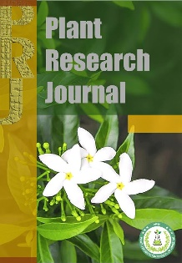
Title

Author Name¹*, Author Name²

¹Name of the Department and Institute, City, State, Country
²Name of the Department and Institute, City, State, Country

*Full name of corresponding author
 ouremail@gmail.com
 Landline: +92(042)99331234 and/or Mobile: +923001234567

Received: dd-mm-yy / Accepted: dd-mm-yy / Published: dd-mm-yy

Abstract
A single paragraph of about 250 words maximum. For research articles, abstracts should give a pertinent overview of the work. We strongly encourage authors to use the following style of structured abstracts, without headings (1) Background: Place the question addressed in a broad context and highlight the purpose of the study (2) Methods: briefly describe the main methods or treatments applied (3) Results: summarize the article’s main findings (4) Conclusions: indicate the main conclusions or interpretations. The abstract should be an objective representation of the article, and it must not contain results that are not presented and substantiated in the main text and should not exaggerate the main conclusions.

Keywords: Keyword 1, Keyword 2, Keyword 3, Keyword 4, Keyword 5

Key message: Key message should not be a copy of the abstract, but a simple text allowing the reader to quickly understand the theme of the current research.

Abbreviations: AB Write full name, CD Write full name, EF Write full name……

1. Introduction

The introduction should briefly place the study in a broad context and highlight why it is important. It should define the purpose of the work and its significance. The current state of the research field should be carefully reviewed and key publications cited.
Please highlight controversial and diverging hypotheses when necessary. Finally, briefly mention the main aim of the work and highlight the principal conclusions. As far as possible, please keep the introduction comprehensible to scientists outside your field of research. References should be written in APA style - e.g., Akram (2025), or (Akram, 2025), or Akram et al. (2025), or (Akram et al., 2025; Sajid et al., 2025).
See the end of the document for further details references.
2. Materials and Methods

The Materials and Methods should be described with sufficient detail to allow others to replicate and build on the published results. Please note that the publication of your manuscript implies that you must make all materials, data, and protocols associated with the publication available to readers. Please disclose at the submission stage any restrictions on the availability of materials or information. New methods and protocols should be described in detail while well-established methods can be briefly described and appropriately cited.
Research manuscripts reporting large datasets that are deposited in a publicly available database should specify where the data have been deposited and provide the relevant accession numbers. If the accession numbers have not yet been obtained at the time of submission, please state that they will be provided during review. They must be provided before publication.
Studies involving animals or humans, and other studies that require ethical approval, must list the authority that provided approval and the corresponding ethical approval code.
In this section, where applicable, authors are required to disclose details of how generative artificial intelligence (GenAI) has been used in this paper (e.g., to generate text, data, or graphics, or to assist in study design, data collection, analysis, or interpretation). The use of GenAI for superficial text editing (e.g., grammar, spelling, punctuation, and formatting) does not need to be declared.

3. Results

This section may be divided by subheadings. It should provide a concise and precise description of the experimental results, their interpretation, as well as the experimental conclusions that can be drawn.
3.1. Subsection
3.1.1. Subsubsection
Bulleted lists look like this:
• First bullet;
• Second bullet;
• Third bullet.
Numbered lists can be added as follows:
1. First item;
2. Second item;
3. Third item.
3.2. Figures, Tables and Schemes
All figures and tables should be cited in the main text as Figure 1, Table 1, etc.

Figure 1. This is a figure. Schemes follow the same formatting.
Table 1. This is a table. Tables should be placed in the main text near to the first time they are cited.
Title 1 | Title 2 | Title 3 | Title 4
Veriable | Data | Data | Data
Veriable | Data | Data | Data
Veriable | Data | Data | Data
Write any footer data

Discussion

Authors should discuss the results and how they can be interpreted from the per-spective of previous studies and of the working hypotheses. The findings and their impli-cations should be discussed in the broadest context possible. Future research directions may also be highlighted.
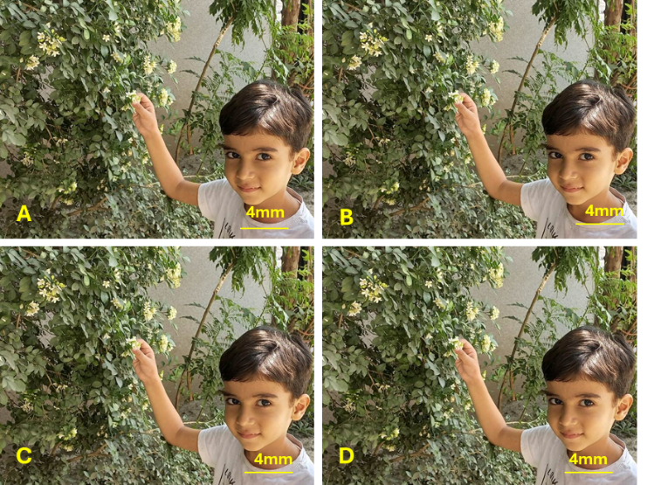
Figure 2. This is a figure. Schemes follow another format. If there are multiple panels, they should be listed as A) Description of what is contained in the first panel, B) Description of what is contained in the second panel, C) Description of what is contained in the third panel, D) Description of what is contained in the fourth panel. Figures should be placed in the main text near to the first time they are cited.
Conclusions
This section can be added to the manuscript if the discussion is unusually long or complex.

Acknowledgements The funding source should be mentioned, and any help or source of the research material should be taken into account.

Author(s) contribution Conceptualization, xxxxxx; methodology, xxxxxx; software, xxxxxx; validation, xxxxxx; formal analysis and investigation, xxxxxx; data curation, xxxxxx; writing—original draft preparation, xxxxxx; writing—review and editing, xxxxxx; supervision, xxxxxx. All authors have reviewed and approved the manuscript.

Conflict of interest The authors declare no conflict of interest.

Data availability All data supporting the findings of this study are available within the paper. We do not have any research data outside the submitted manuscript file.

Declarations
Consent for publication Not applicable.

Competing interests The authors declare no competing interests.

References
References must be written in APA style and arrange alphabetically. We recommend preparing the references with a bibliography software package, such as EndNote, ReferenceManager or Zotero to avoid typing mistakes and duplicated references. Include the digital object identifier (DOI) for all references where available.
Citations and references in the Supplementary Materials are permitted provided that they also appear in the reference list here.

Journal article
Akram, M., Sajid, S.A. & Aqib, F. (2025). Strategies that could be adopted to improve the nutritional quality of food and food products. Plant Research Journal, 00(00), 00-00.

Book
Akram, M., Sajid, Z.A., & Aftab, F. (2025). Plant Tissue Culture and Biotechnology (2nd ed.). Springer Nature.

Book chapter
Nadeem, M. (2025). Micropropagation. In M. Akram, Z.A. Sajid, & F. Aftab (Eds.), Plant Tissue Culture and Biotechnology (2nd ed., pp. 200–250). Springer Nature.

Online source
Akram, M. (2025, July 7). Micropropagation. https://www.rhs.org.uk/propagation/micropropagation.

Publisher’s note: PPSP remains neutral about jurisdictional claims in published data and institutional affiliations.

